1. A) Create two series as shown using pd.series() function.Series_A = [10,20,30,40,50] Series_B = [40,50,60,70,80]. Get the items common to both.

B) Create a data frame with following data

|  |  |  |  |  |
| --- | --- | --- | --- | --- |
| Ename | Type | Dname | exp | salary |
| Roshan | regular | cs | 10 | 50000 |
| Amar | adhoc | cs | 20 | 15000 |
| Ashwini | regular | ec | 5 | 30000 |
| Lohith | adhoc | ec | 14 | 15000 |
| Mohan | contract | cs | 9 | 10000 |
| Pramod | regular | ec | 8 | 40000 |

1. Make a pivot table that shows the average salary of each employee for each department.
2. Make a pivot table that shows the sum and mean of the salaries of each type of employee and the number of employees of each type.
3. You have come across some missing data in your data set. How will you handle it?
4. To start Linear Regression, you would need to make some assumptions. What are those?
5. How do you clean up & organize large datasets? Explain briefly?
6. How does Netflix use Machine learning?
7. Explain workflow in machine learning using a day-to-day life example with diagram?
8. Define IOT, AI, BLOCKCHAIN & analytics are emerging technologies enabled by the cloud analyze the three-way relationship between IOT,CLOUD &AI?
9. Cloud provider owns, manages & maintains the physical resources. Define this cloud service model?
10. A) Describe the different types of machine learning algorithms with examples.

B) What are the goals of artificial intelligence?

1. A) Use'Cars93' dataset to answer the below questions.The information that the columns of this dataset contain is given below:

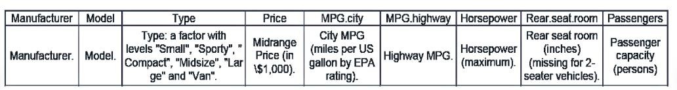

Create the following plots to visualize/summarize the data and customize it appropriately.

• Use a box plot to determine the price range of all different cars available in the market? And interpret the five-number summary

• Histogram to check the frequency distribution of the variable ‘Mpg.city’ (Miles per gallon) and note down the interval having the highest frequency.

• Use a scatter plot to determine whether a car with higher horsepower gives lower mileage?

• Use a line chart to observe the variations in ‘Engine Size', against 'Horsepower'.

• Create a git repository and push source code to the repo

3 B) Solve the following

1. Find a list of squares of the first five odd numbers using lambda and map function.
2. find the odd numbers from a given list using a filter
3. Compute a sum of the first five integers using reduce function.
4. A) Use the 'matcars.csv’ dataset to answer the above questions.

* Create the following plots to visualize/summarize the data and customize it appropriately.
* Histogram to check the frequency distribution of the variable ‘mpg’ (Miles per gallon)and note down the interval having the highest frequency.
* Scatter plot to determine the relationship between the weight of the car and the mpg
* Bar plot to check the frequency distribution of transmission type of cars.
* Box and Whisker plot of mpg and interpret the five-number summary.
* Create a git repository and push source code to the repo.

B) Write a Pandas program to split a given dataframe into groups and create a new column with count from GroupBy.

Test Data:

|  |  |  |  |
| --- | --- | --- | --- |
|  | book_name | Book_type | Book_Id |
| 0 | Book1 | Math | 1 |
| 1 | Book2 | Physics | 2 |
| 2 | Book3 | Computer | 3 |
| 3 | Book4 | Science | 4 |
| 4 | Book1 | Math | 1 |
| 5 | Book2 | Physics | 2 |
| 6 | Book3 | Computer | 3 |
| 7 | Book5 | English | 5 |

1. A) Create a df using Numpy modules aggregation function ,Vector, Map, filter, reduce and

B) .Find odd and even number from a given list using a filter Lambda function List[1,2,3,4,5,6,7,8,9,10]

1. A) Create a dataframe as following using pandas.

B) Create a data frame with following data

a. Make a pivot table that shows the average salary of each employee for each department.

b. Make a pivot table that shows the sum and mean of the salaries of each type of employee and the number of employees of each type.

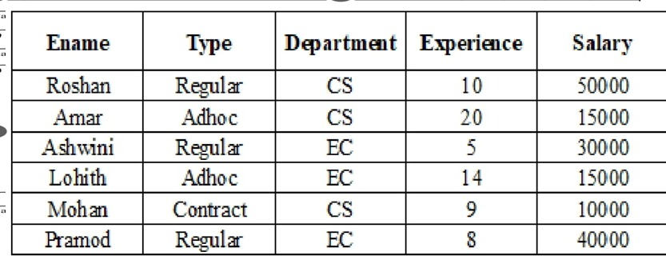

1. Consider the credit card dataset which contains the following columns:

● Create a bivariate (scatter plot) plot to find if there is a correlation between credit card limit and average purchase made on the card.

● Visualise the distribution of values for credit card limit and average purchase made on the card. Also, identify the outliers in the data, if any.

● Provide a visual representation of the number of customers in each income group using a bar chart.

● Plot the frequency distribution of the total transaction amount.

● Graphically represent the percentage of customers retained and those attrited. Highlight the latter by slicing it apart from the main pie.

1. Create the following plots to visualize/summarize the data and customize it appropriately.

* Histogram to check the frequency distribution of the variable ‘mpg’ (Miles per gallon) and note down the interval having the highest [0,3 2,5 2,3,4 15] frequency.
* scatter plot to determine the relationship between the weight of the car and the mpg
* bar plot to check the frequency distribution of transmission type of cars.
* Box plot of mpg and interpret the five-number summary.
* Create a git repository and push source code to the repository

1. Consider the rainfall dataset. This data contains region(district) wise rainfall across India. Perform the following operations for the dataset

a.Find the district that gets the highest annual rainfall.

b.Drop the columns 'Jan-Feb', 'Mar-May', 'Jun-Sep', 'Oct-Dec'.

c. Display the state-wise mean rainfall for all the months using a pivot table.

1. A) In recent Your most of the Companies are turning to text based chatbox for resolving Consumer queries. What is the reason for it & how is it impacting the business.

B) Chess game / online trading /cyber-attack / not entertainment Shopping/Medical Services (health care).

1. Assume proper Dataset and apply different kinds plot using matplotlib.
2. Assume Stock Dataset and visualize Time series data using pandas.With Industry 4.0, artificial intelligence is finding place in every aspect of life. What happens if Al replaces humans in the workplace?
3. For the given scenarios you are required to build an Al solution. Which Al techniques can be applied/best suited for stated problems. Justify
4. Extract and digitize the customer information from the Know Your Customer (KYC)
5. To identify if employees are wearing face mask in the office campus
6. To identify and narrow down tumour regions and further predict if the tumour is process
7. To identify the location of a moving car within an image
8. Automated inspection and cost estimation step in the Insurance claim business
9. Which technique help in addressing certain complex problems with higher accuracy and better generalization characteristics much like human brain in Computer Vision, Natural Language Processing and Speech Domains? And why?
10. For the following scenarios you are required to build a predictive model. Which machine learning technique/ algorithm can be applied / best suited for stated problems. Justify your recommendation.
11. Predicting the food delivery time
12. Predicting whether the transaction is fraudulent
13. Predicting the credit limit of a credit card applicant
14. To group similar customers of an online grocery store, based on their purchasing patterns, to offer discounts to its customers.
15. Predict the probability of a mechanical system breakdown, based on its system vibration and operating temperature
16. How do you clean up & organize large datasets? Explain briefly?
17. Cloud provider owns, manages & maintains the physical resources. Define this cloud service model?
18. if an organization needs to run highly sensitive & mission critical application with unpredictable performance & capacity Requirements, which model would be best to meet its requirements
19. Is it possible to run completely different operating systems on virtual machines that are on single host? If yes, what makes this possible
20. Cloud adoption is an integral part of application modernization. What are the other two important components of modernization?